## Week 1

In this week, communication with the sponsor began. In the correspondence, the project requirements were re-assessed. These are:

To build a pilot study to test logistics and gather information, thus being able to better determine how the main study can be approached, as well as backing up previous research in this field.

To educate users on history with VR through a simulation of the Palace of Versailles.

To design a series of questionnaires that will determine the effectiveness of VR education in history and how it compares to textbook education in history.

To gather appropriate qualitative and quantitative data through the use of the aforementioned questionnaires.

To analyse the gathered data with content analysis and represent it in comprehensible graphs.

To test the simulation with participants that will interact with the environment and learn history through VR.

To determine conclusions based on the gathered data from both the graphs and qualitative data obtained from the questionnaire.

To deliver a 3D virtual model of the Palace of Versailles, and a virtual tour within this Palace of Versailles model that teaches users about history through the use of VR.

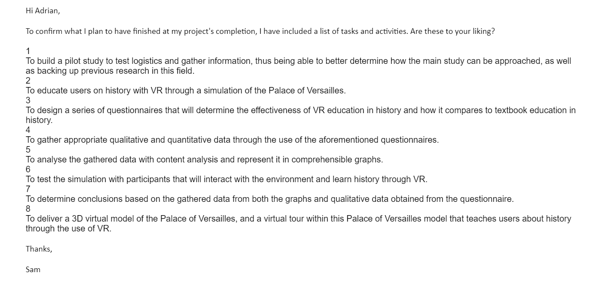

It was determined that the current project plan was acceptable and that now the requirements can be properly analysed.

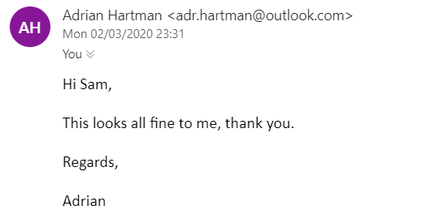

Already existing software like *Titanic VR* was closely examined, and similar research already collected from the literature review was also obtained. The requirements for software, personnel and hardware were also gone over again to ensure unforeseen issues do not appear. These have already been covered in the previous action plan. They can be viewed again in Appendix A.

The first week illustrates that the project’s schedule outlined in the plan is being kept to. By keeping to the project schedule, chances of scope creep are kept small. With the requirements confirmed with the sponsor, the next steps will be completing the analysis of requirements from personnel, software and hardware, as well as comparing the project to pre-existing software and research. The pilot study will also be begun.

At the end of week 1, the Project Plan and Gantt Chart look like this:

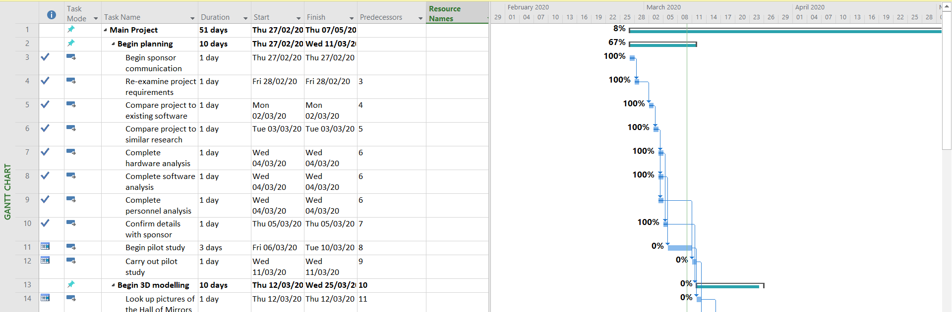

## Week 2

In this week, the model for the pilot study was developed. This model was a 3D emulation of the Mausoleum of Theodoric, a 5th century stone monument in Italy. While development began in 3DSMax, the software of choice was later chosen instead to be Blender, due to Blender being able to be accessed from other facilities than ones at college. This allows the project to be worked on at home, reducing chances of scope creep.

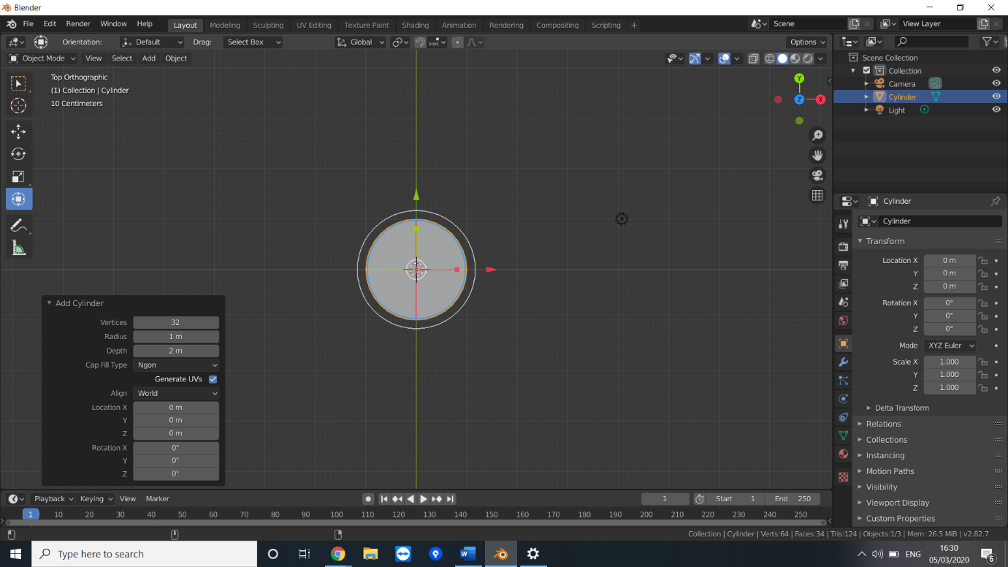

The mausoleum was drawn out with three sections: the top dome, and two decagonal (ten-sided) cylinders. In the image below the vertices were modified to 10.

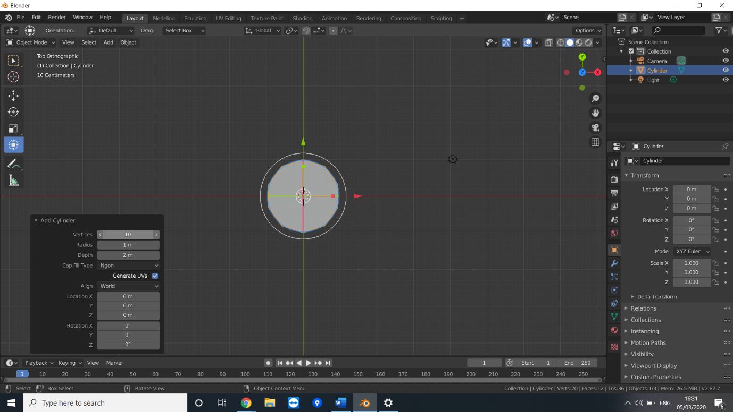

From there, the size of the cylinder was extended, to roughly simulate the size of the top decagon. A sphere was then drawn and cut in half to simulate the dome on top. Due to the 12 segments that protrude from the roof, the sphere was given 36 vertices to ensure the segments would appear evenly across the dome.

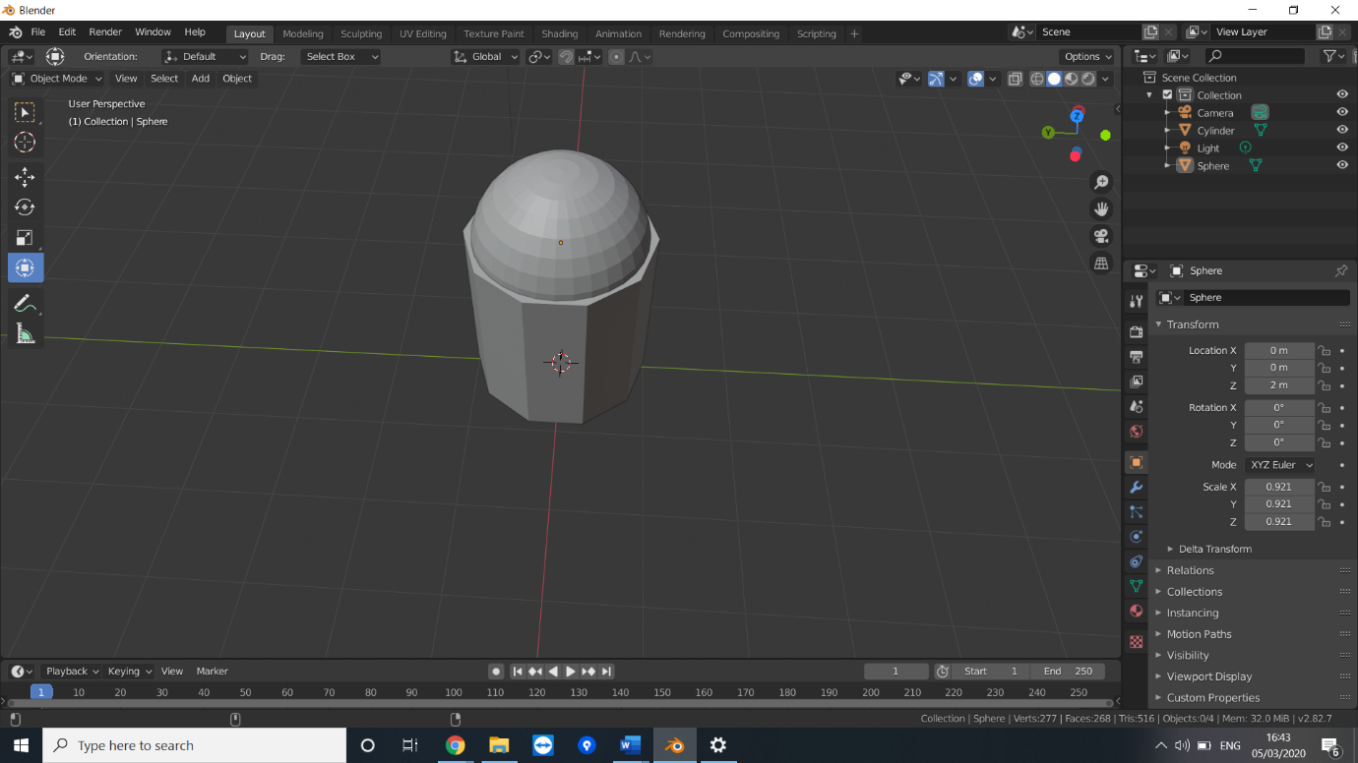

The hemisphere was then dragged on top of the already drawn decagon. The hemisphere was drawn to ensure it was slightly smaller than the decagon, to successfully emulate how the mausoleum appears in real life. Due to the dimensions of the shapes in Blender being different to the mausoleum, they were shrunk on the z axis to flatten them out.

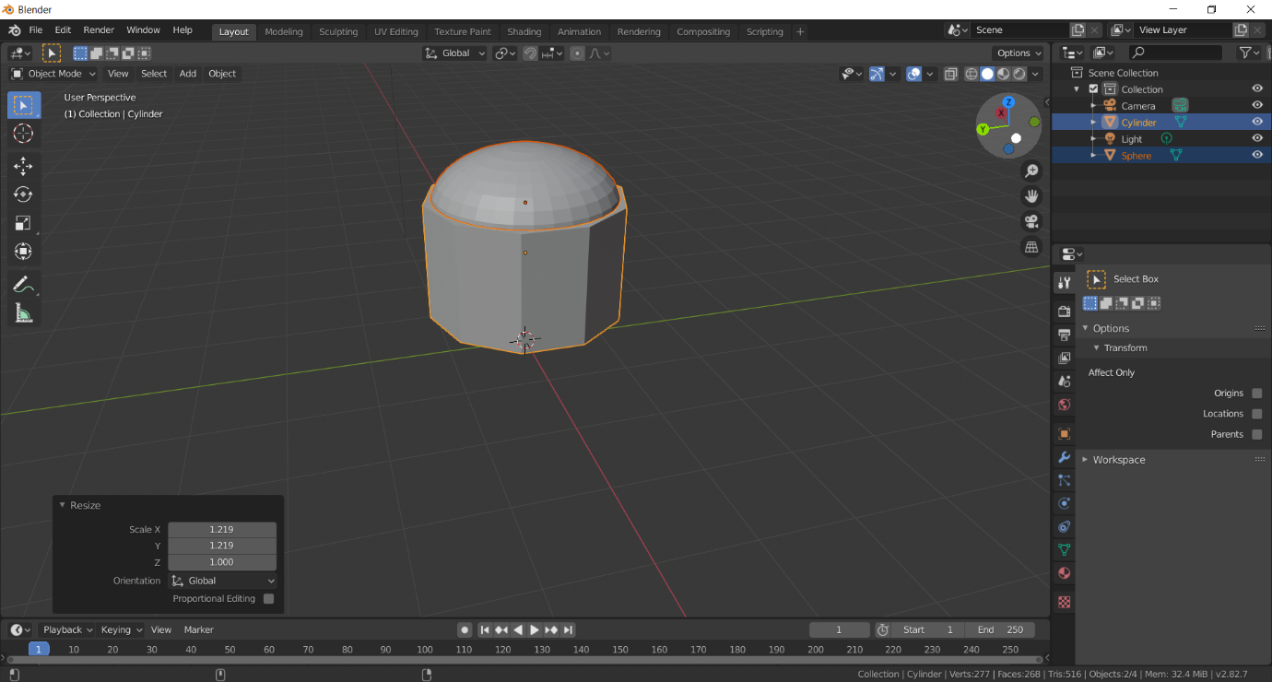

After this, every 3rd face was selected and pulled up to a height representative of the mausoleum.

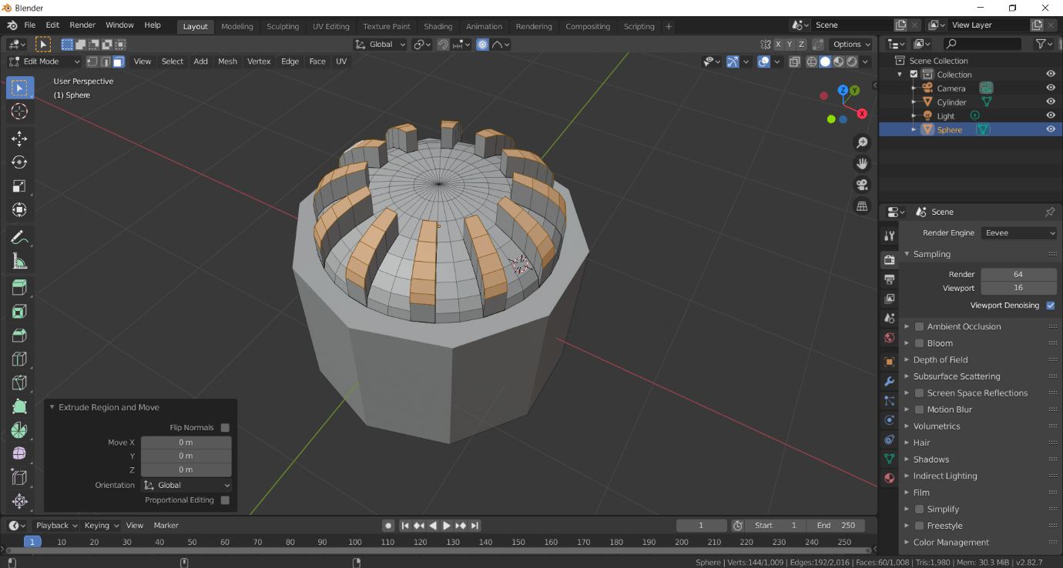

From here, the segments were appropriately adjusted to reflect their flat tops. This proved to be the most challenging part of the modelling this week, as each vertex had to be individually trimmed and adjusted. This went through several iterations, one of which can be seen below.

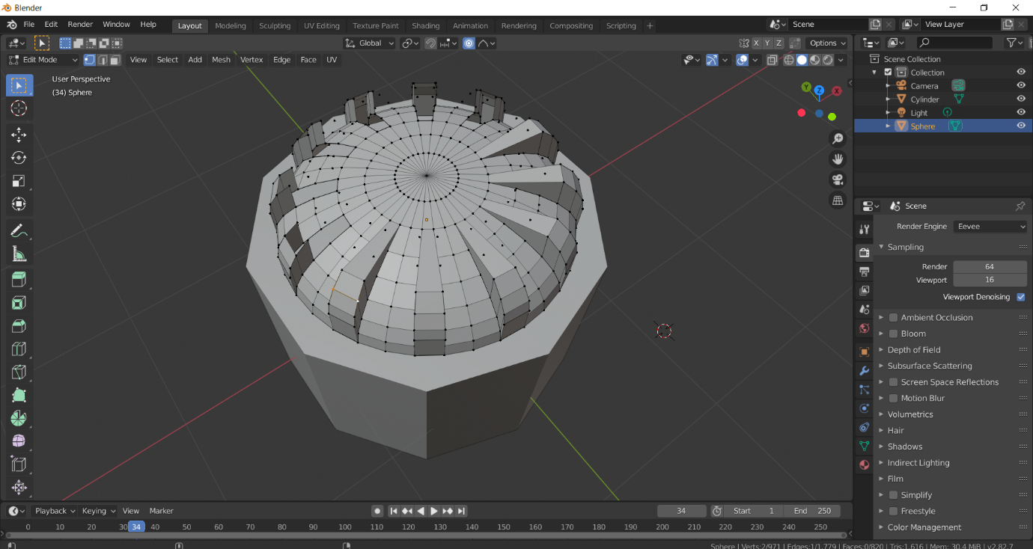

This iteration, however, was abandoned in favour of using vertices from the raised section that were already on the same z-axis as ones left alone. From here, the faces, edges and vertices were either adjusted to deleted to achieve a final model that’s representative of the mausoleum’s roof. This is displayed below.

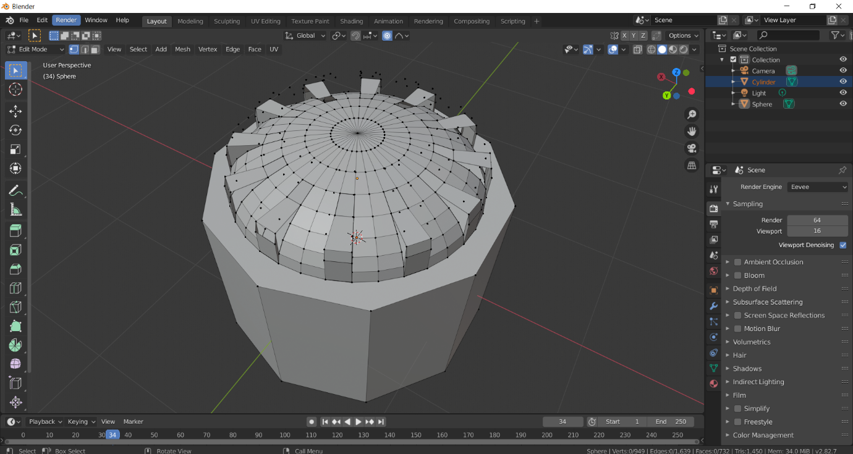

From here, a new decagon was drawn while taking into account the dimensions of the mausoleum in real life. It was then placed underneath the first decagon to complete the exterior of the mausoleum.

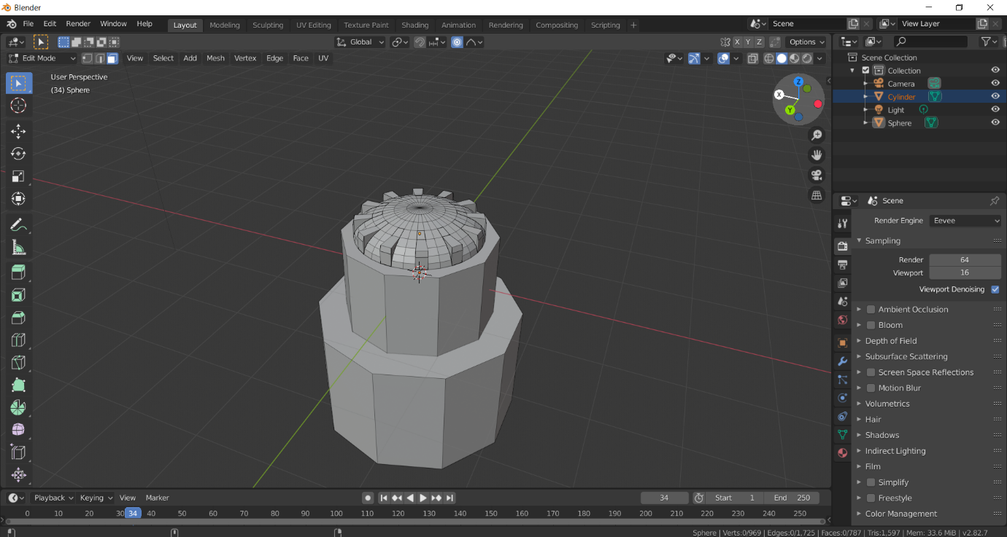

While designing the exterior was challenging, and at times did not go as well as planned, it was still ultimately completed. As well as understanding how to better utilise Blender for future developments in the project, the pilot study exists to also demonstrate any potential risks and constraints from the main project, such as inexperience with the software. It also allowed myself to determine 3DSMax would be a less appropriate tool to use than Blender. In the next week, the model’s interior will be carved out and the pilot study can commence. Afterward, the 3D modelling can be begun.

The project plan as of week 2 is shown below:

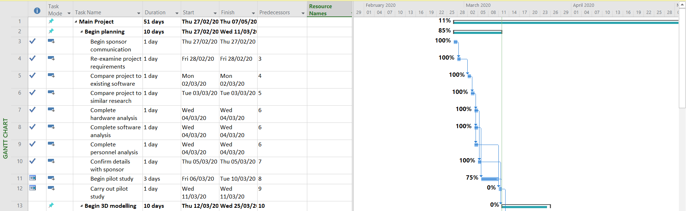

## Week 3

In this week, the pilot study was planned to be finished and the main study to be begun.

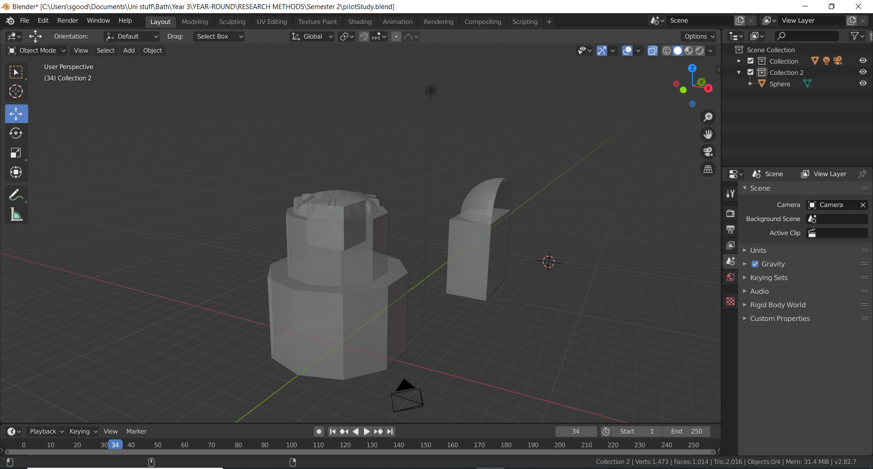

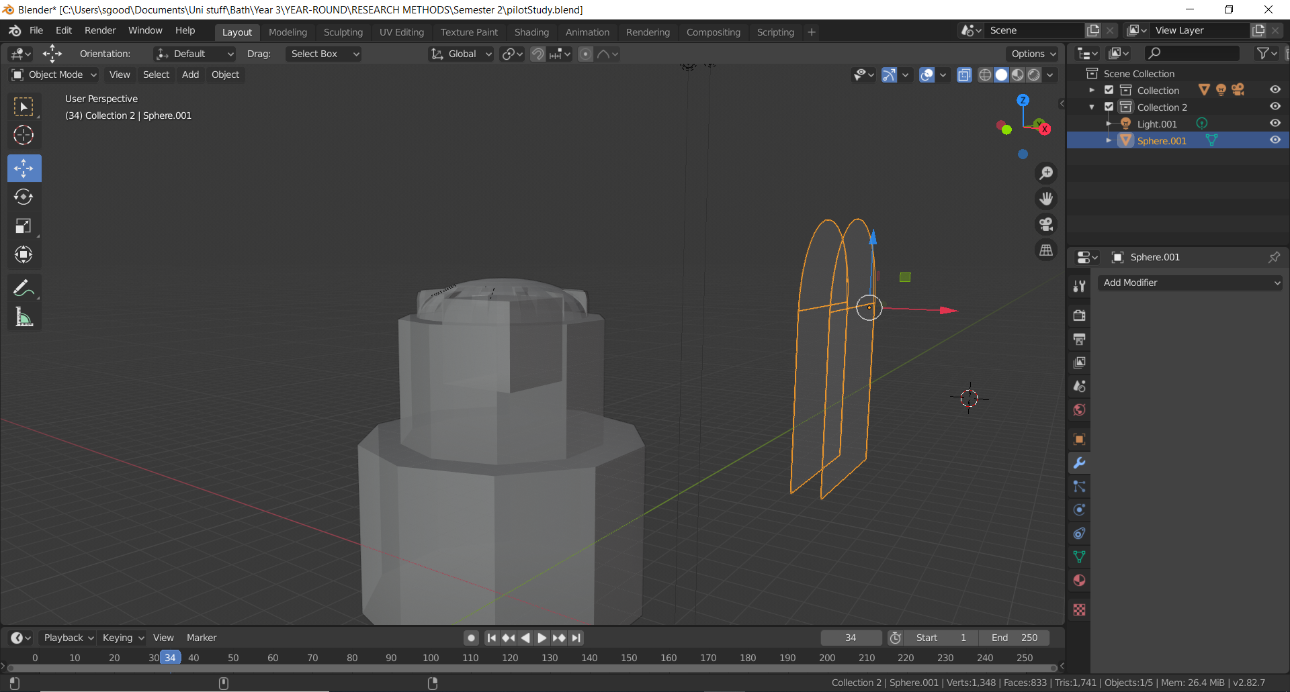

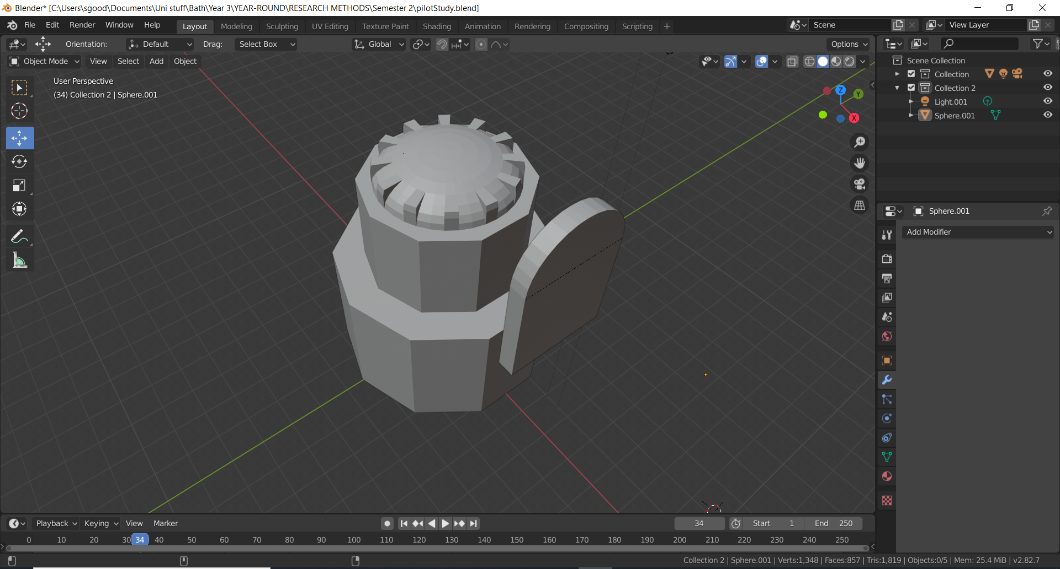

## Week 4

This week, the pieces for the main project began to be modelled. The first pieces modelled here were the windows, which were built as 2x10 rectangles in accordance with how the mirrors really looked. Doing research online showed that the Hall of Mirrors’ dimensions are 73m x 10.5m x 12.3m.

Before continuing with modelling, the Measurelt tool was added, to allow clear measurements of dimensions to display when necessary.

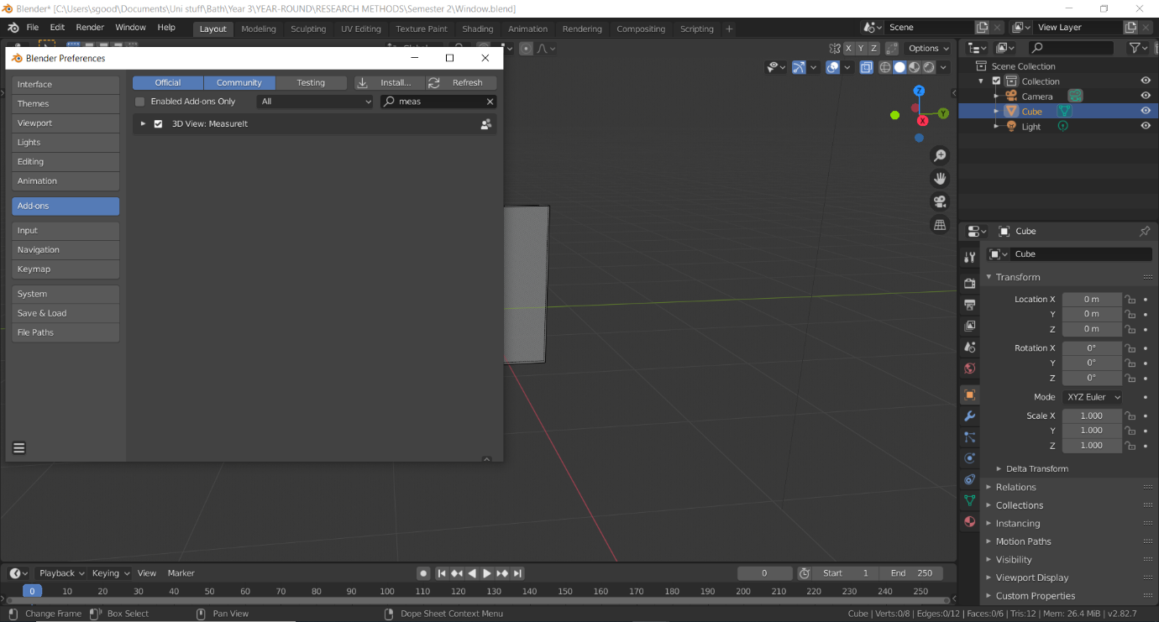

These sizes were kept in mind when the windows were developed and will continue to be kept in mind as the project progresses. Due to not having an exact measurement of each window pane, an estimate of 1 foot (roughly 0.3m) was made and used as the standard for each pane.

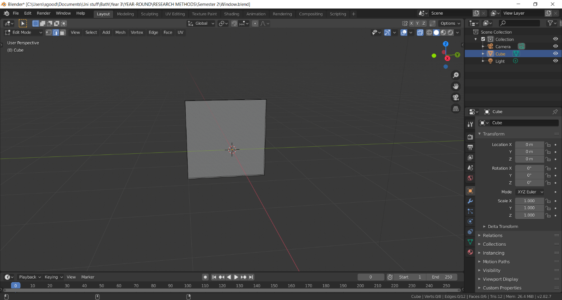

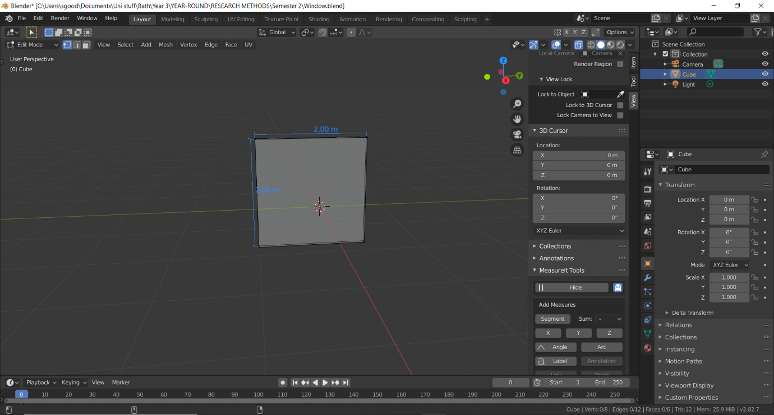

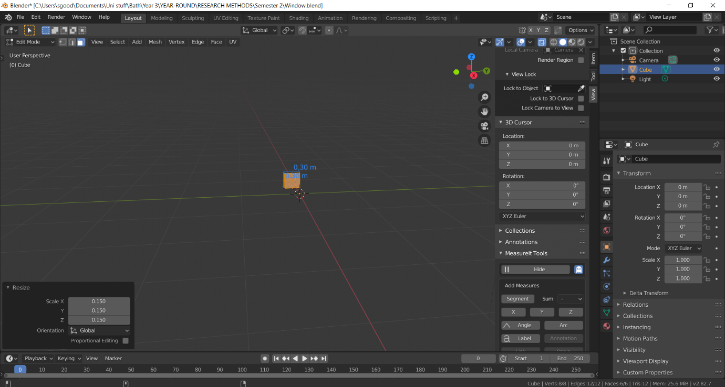

Later in development, the size was multiplied by 4 when it was decided that modelling the panes individually made less sense than modelling them as a set of 4.

Once the dimensions of the window were set more accurately, they were subdivided into 4 sections.

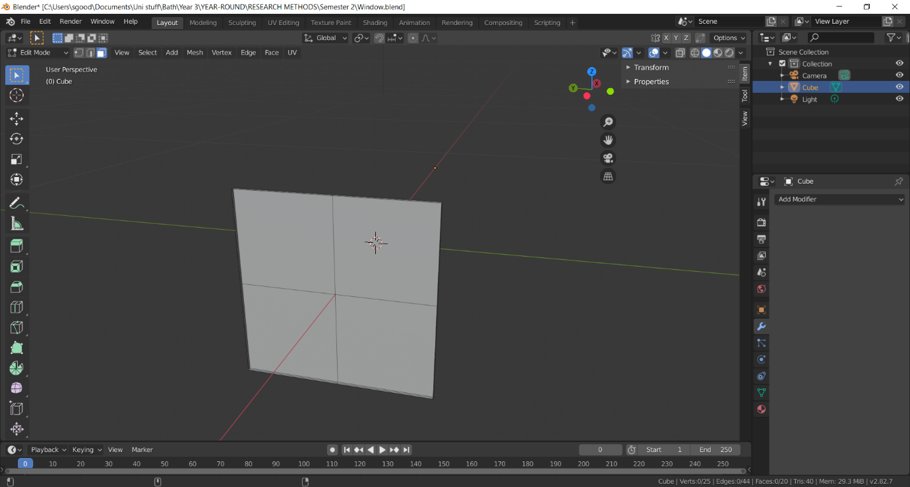

From here, each face was selected and the inset tool was used twice:

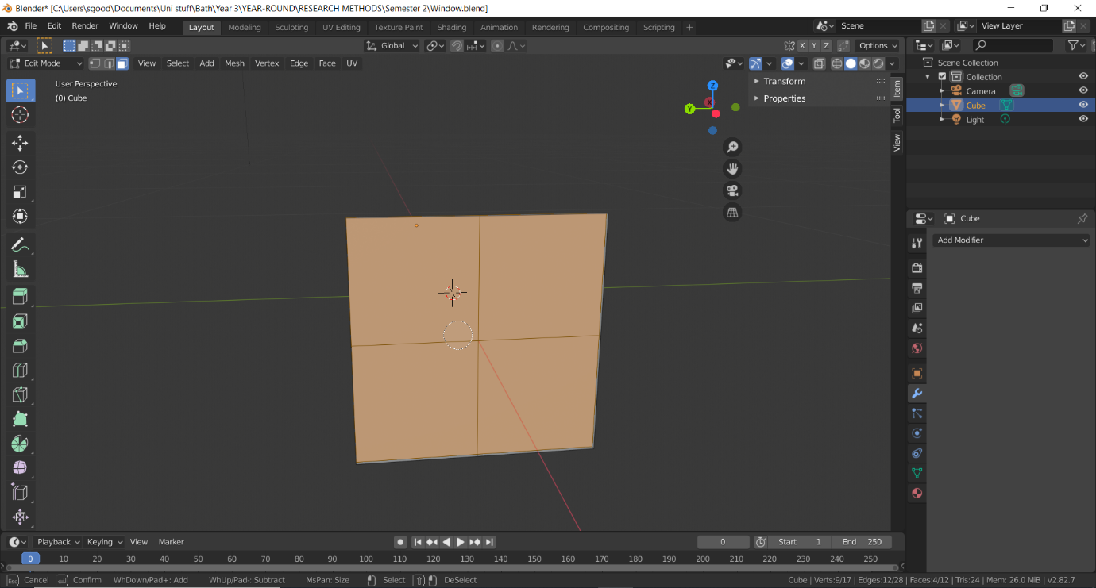

First, it was used to create a border for the window as a whole.

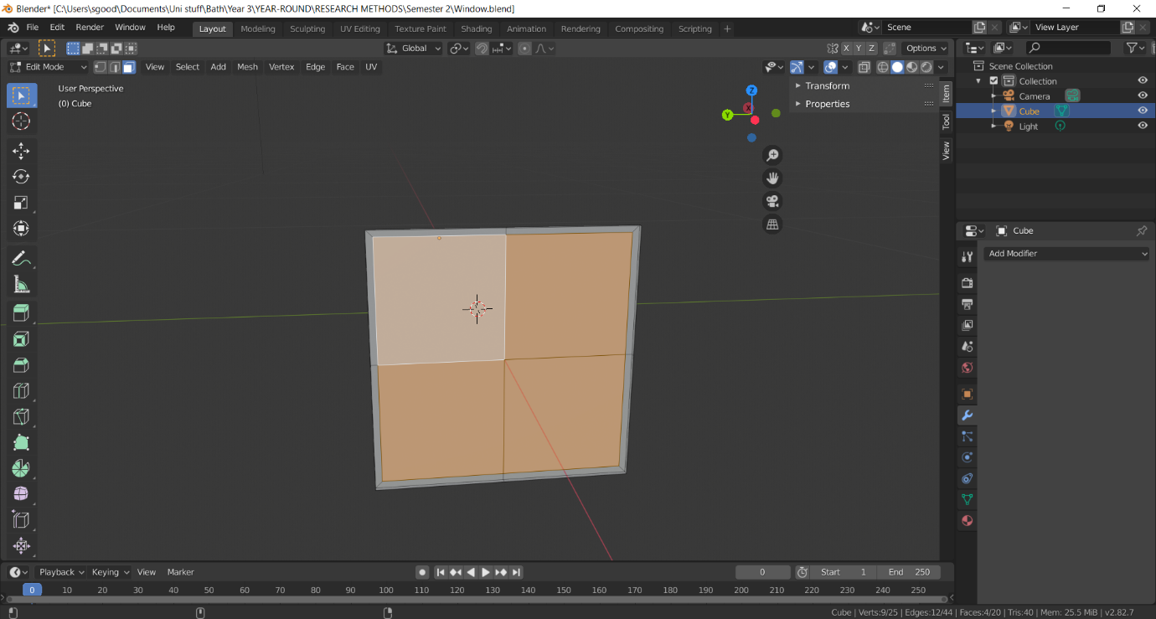

Secondly, it was used to create borders between the 4 panes.

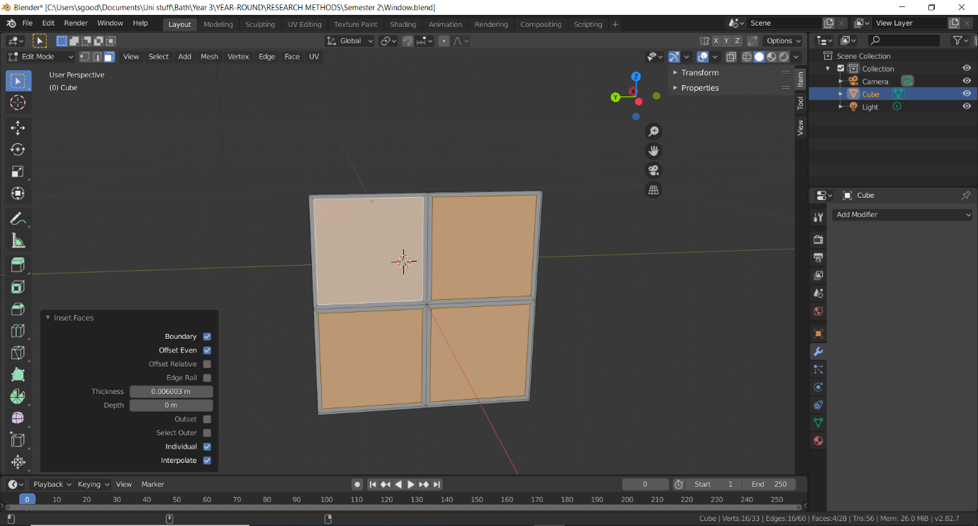

The inset tool was then used again in conjunction with the extrude tool to push the windows back and give the window more accurate dimensions.

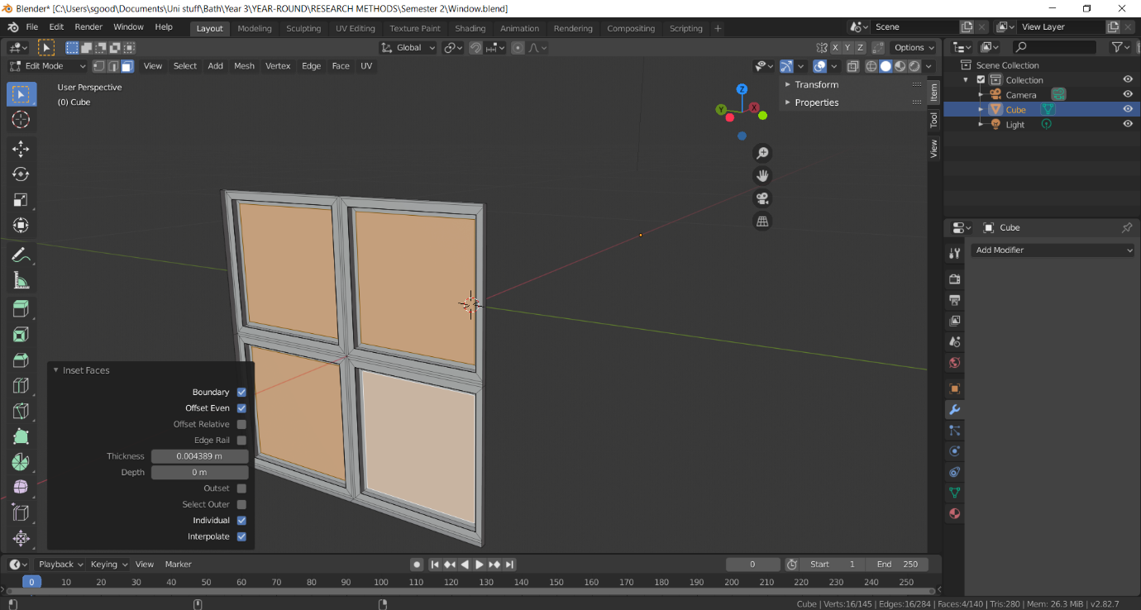

From here, the glass sections were deleted.

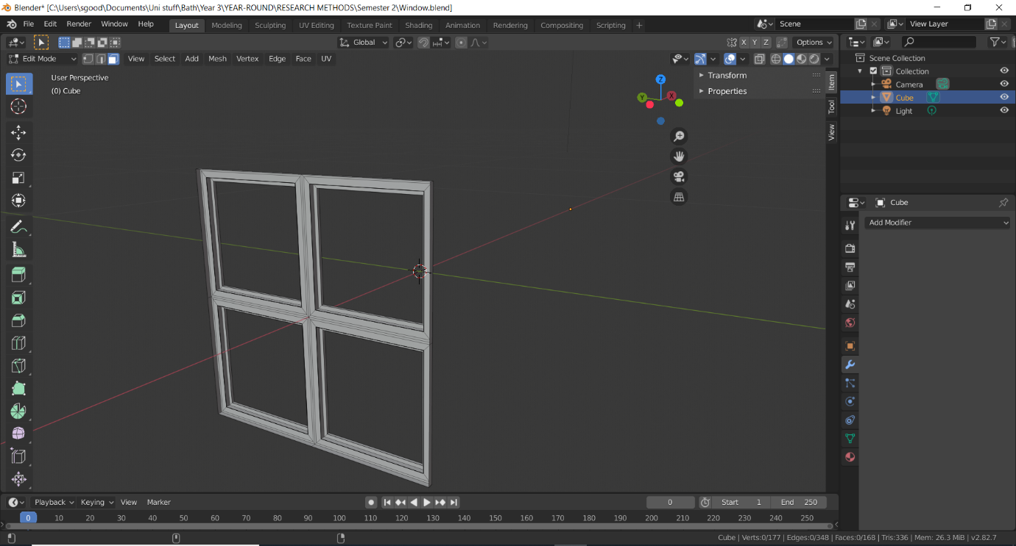

These holes were later refilled as a new object, with a new “glass” material applied to them.

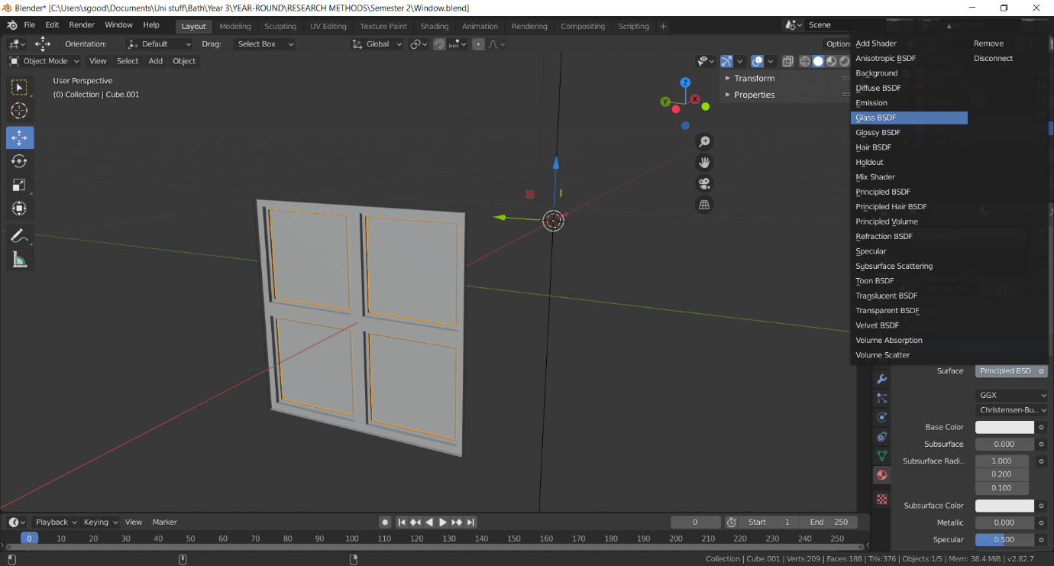

As previously mentioned, because it was decided to work in units of 4 would make more sense, the window was increased by 4 times its previous size to 1.2 metres.

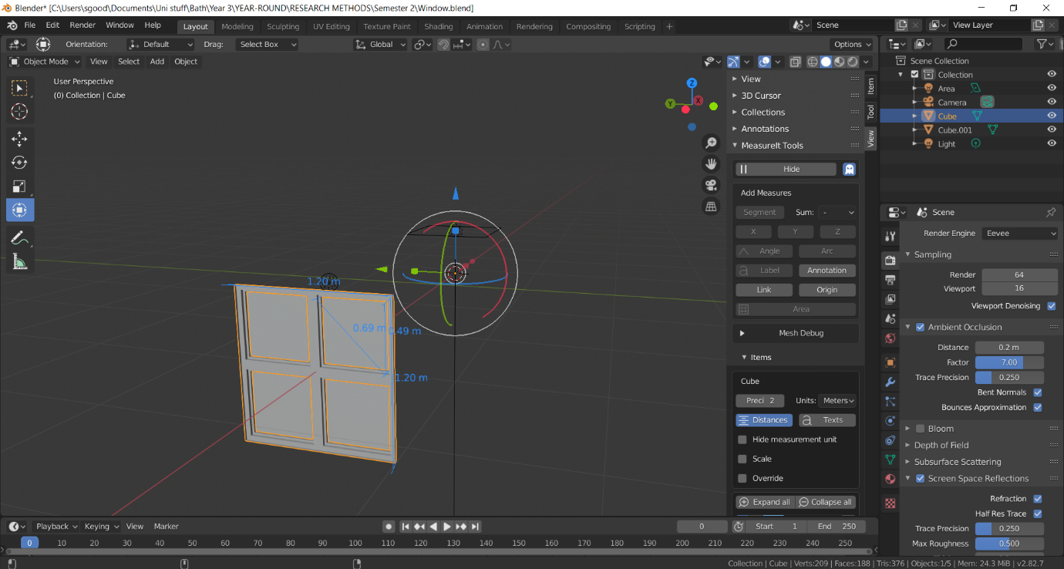

By duplicating the model, new window was created.

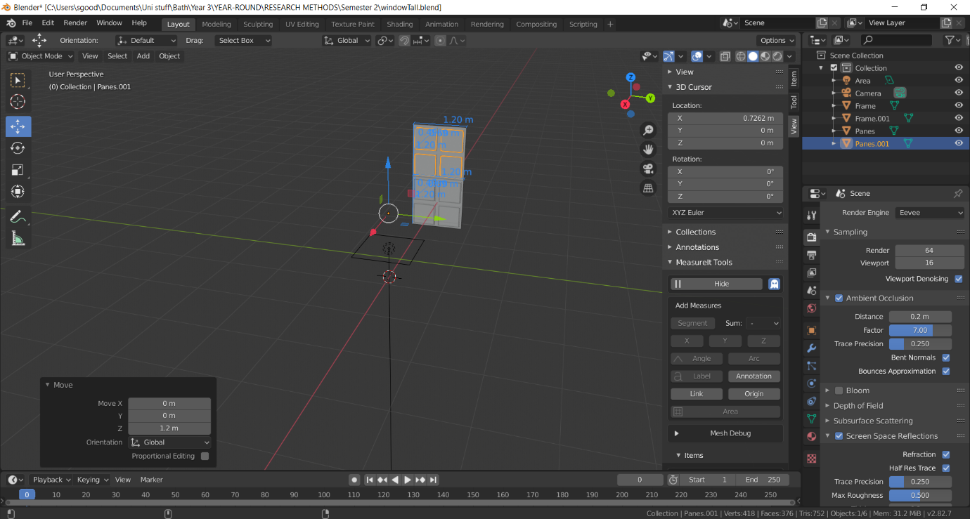

The move tool was used to accurately space the window out.

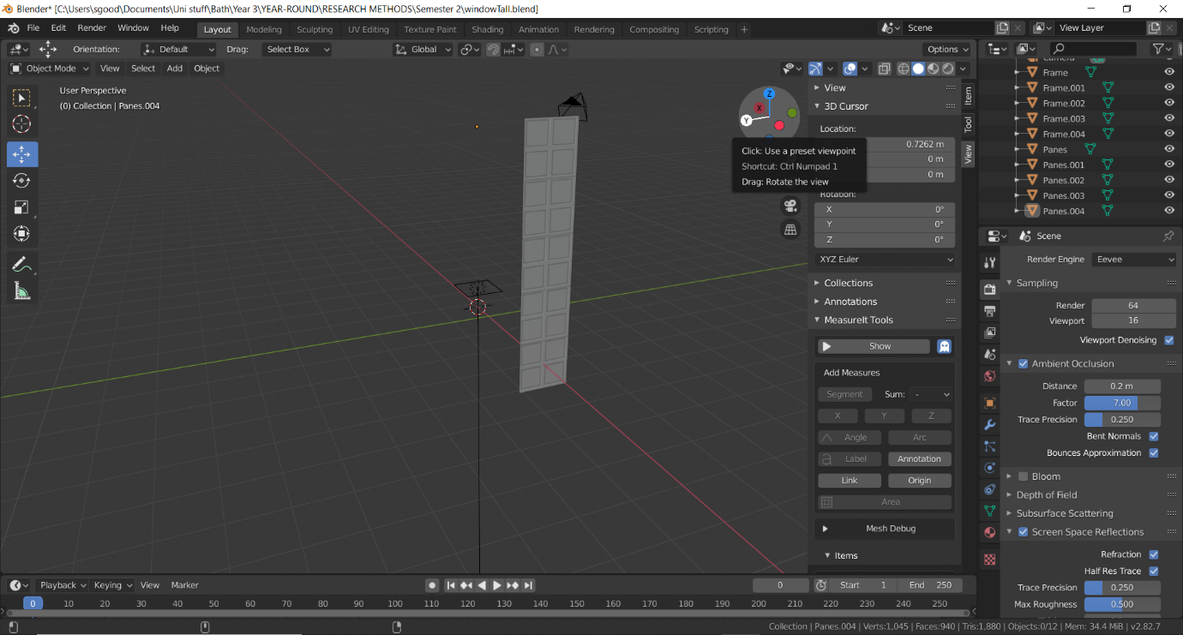

This step was continued until we were left with a window representative to the one found within the Hall of Mirrors.

To create the top window, a semi-circle was required. To do this, a sphere was created and all but its center vertices were deleted. Its bottom vertices were then delete, leaving the top half.

These vertices were then filled to create a semi-circle, which was then extruded into the object seen below.

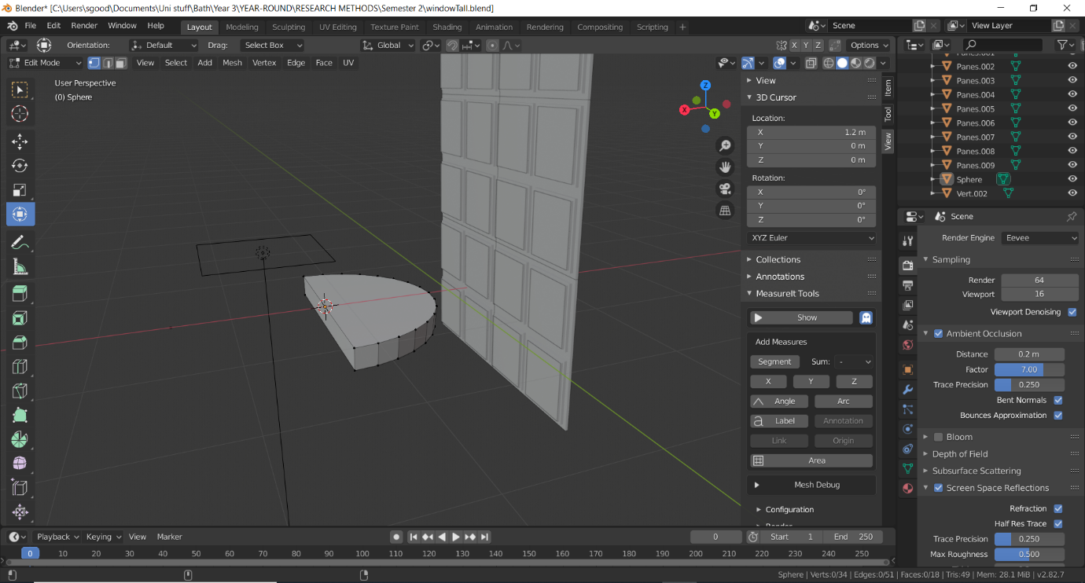

The tall window was then pasted and put to the side of the old window, creating a 4x10 window panel.

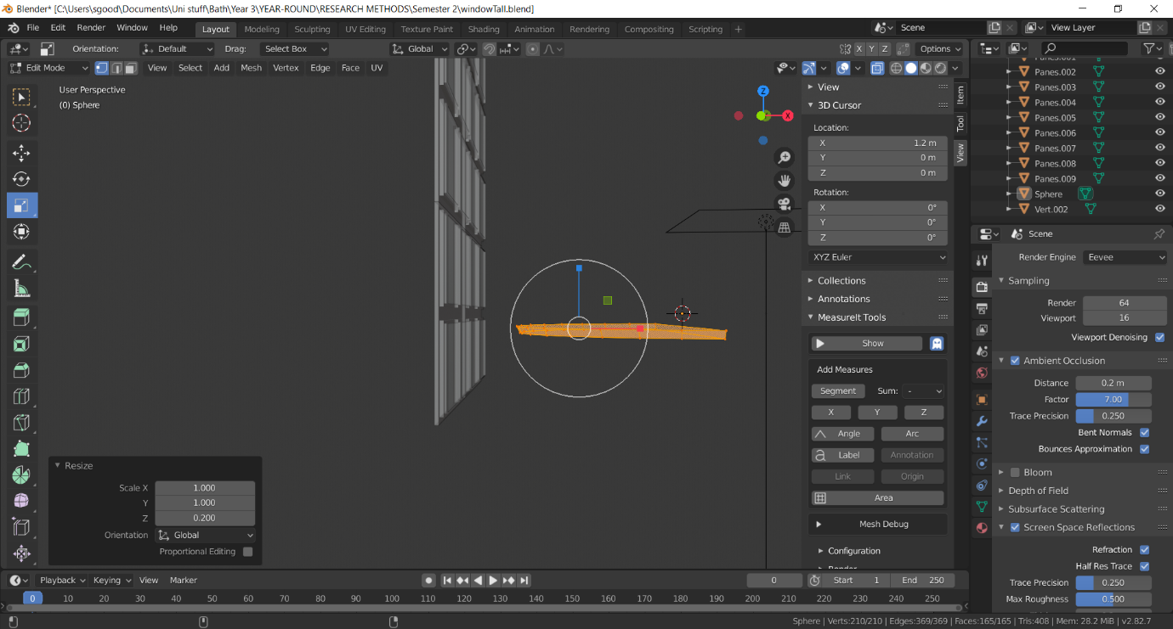

The top window was then flattened and given the same material as the glass windows, before being put on top of the windows.

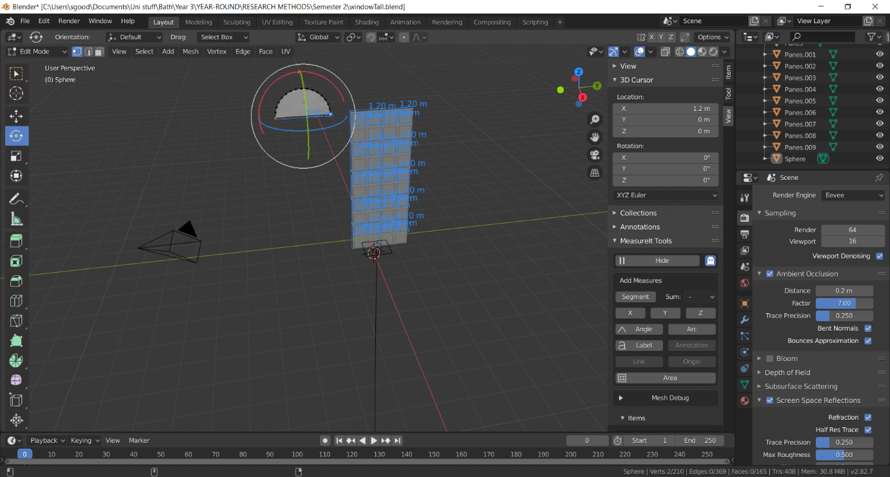

This left us with the finished product.

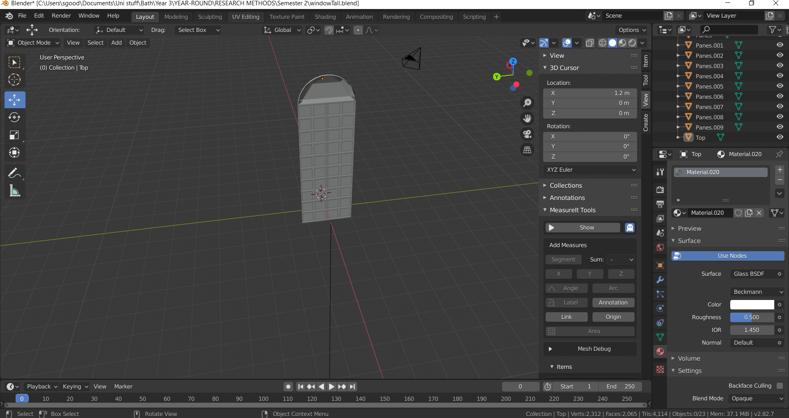

After this, the archway began to be modelled. This was begun by taking a standard cube from Blender and stretching it out.

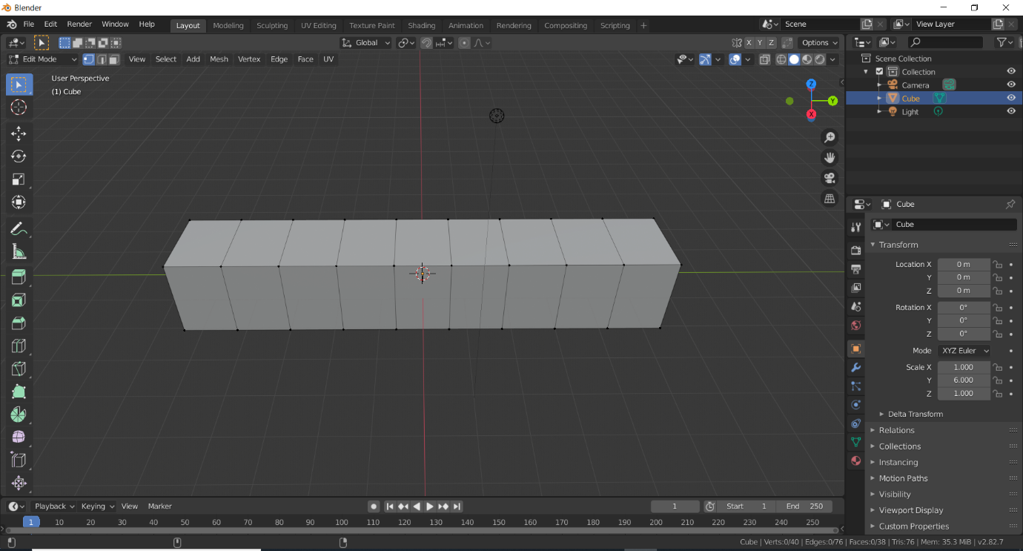

From here, it was segmented into 10 separate pieces.

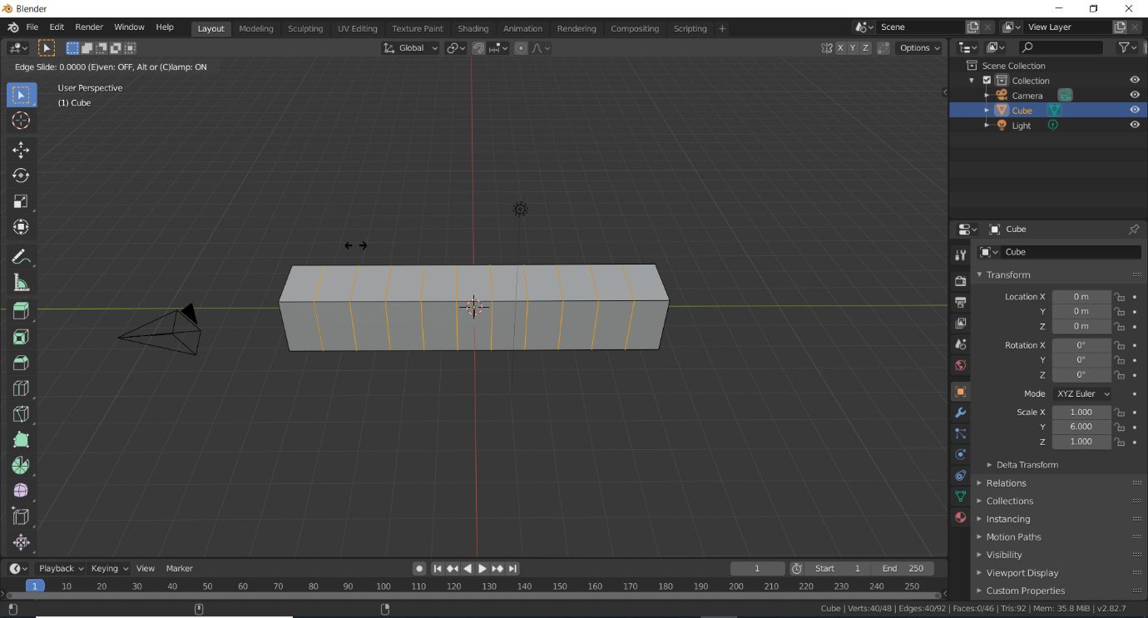

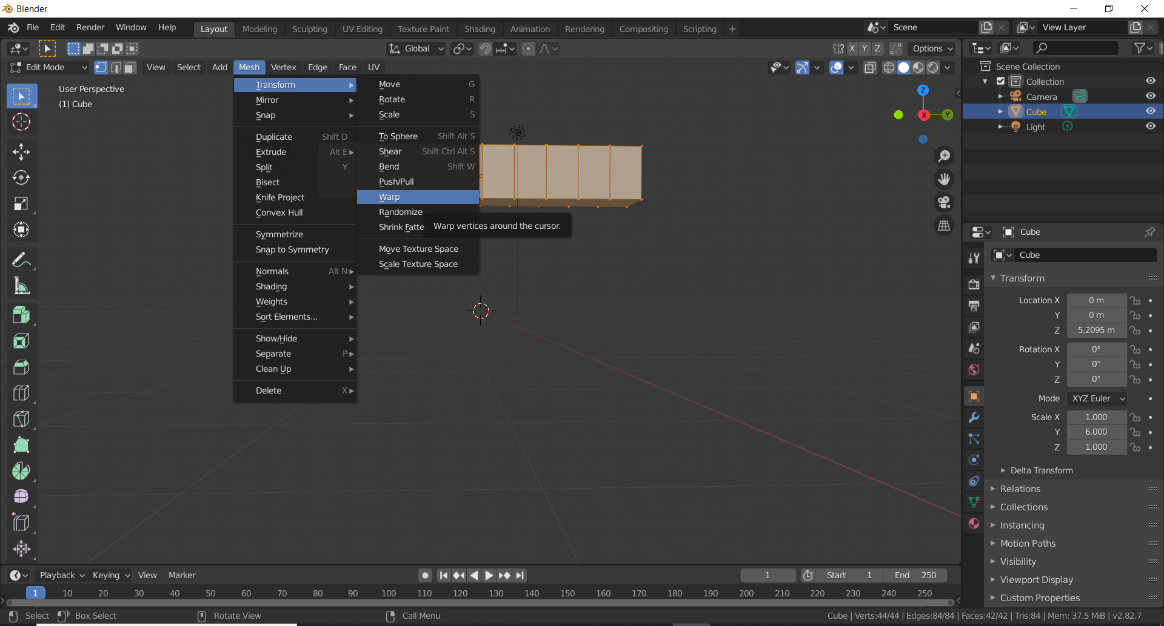

From here, the angle should be adjusted to 180 degrees, forming an archway as shown below. 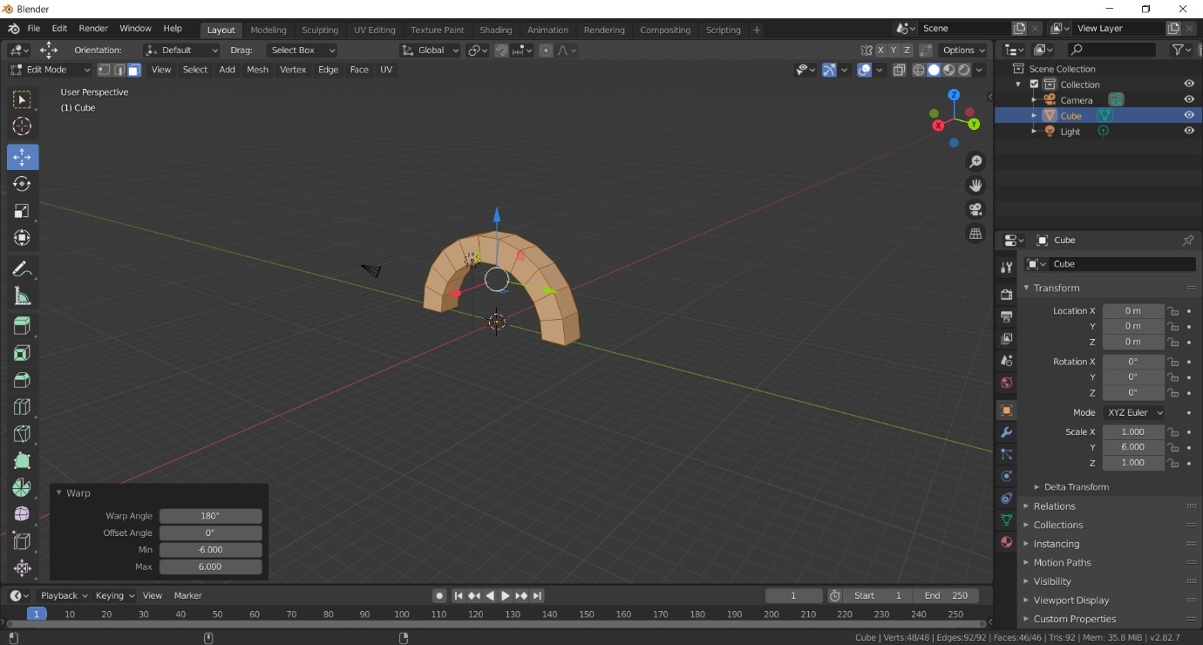

From here, the faces on the bottom were selected, and then dragged down.

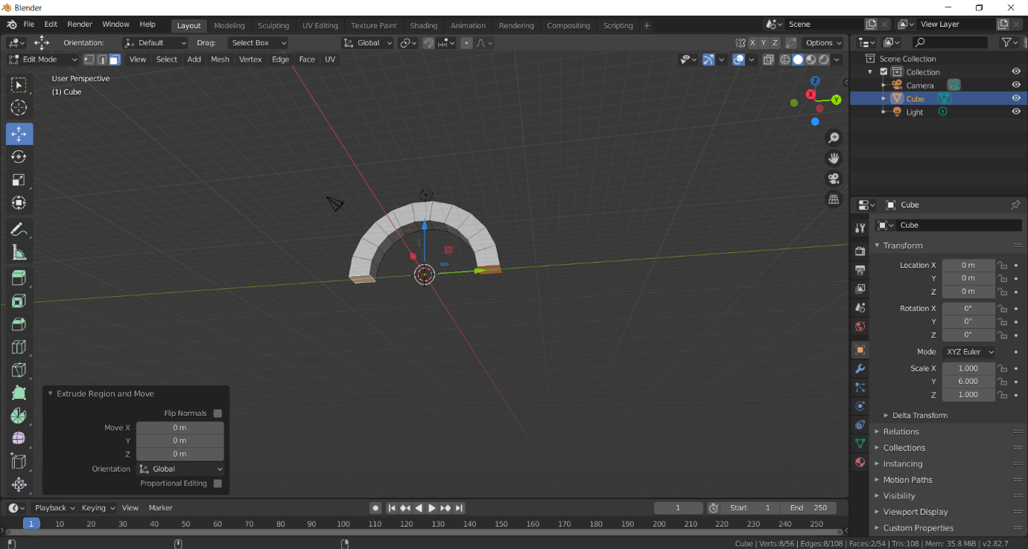

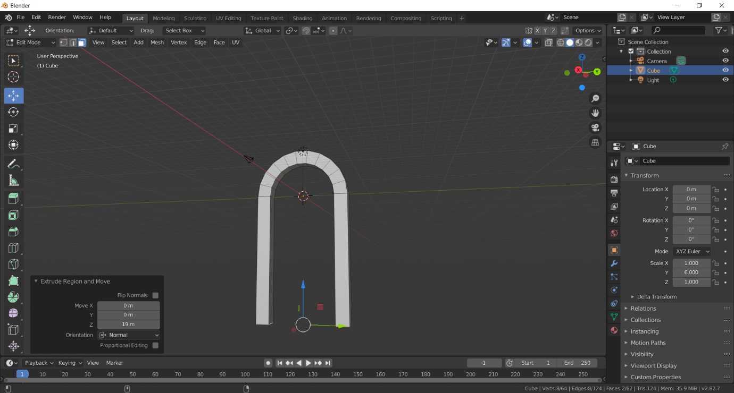

From here, the basic form of the archway was complete. However, decoration was a necessary addition, so development on it continued. To display its second layer of stone, the sections minus the bottom feet were again inset and extruded.

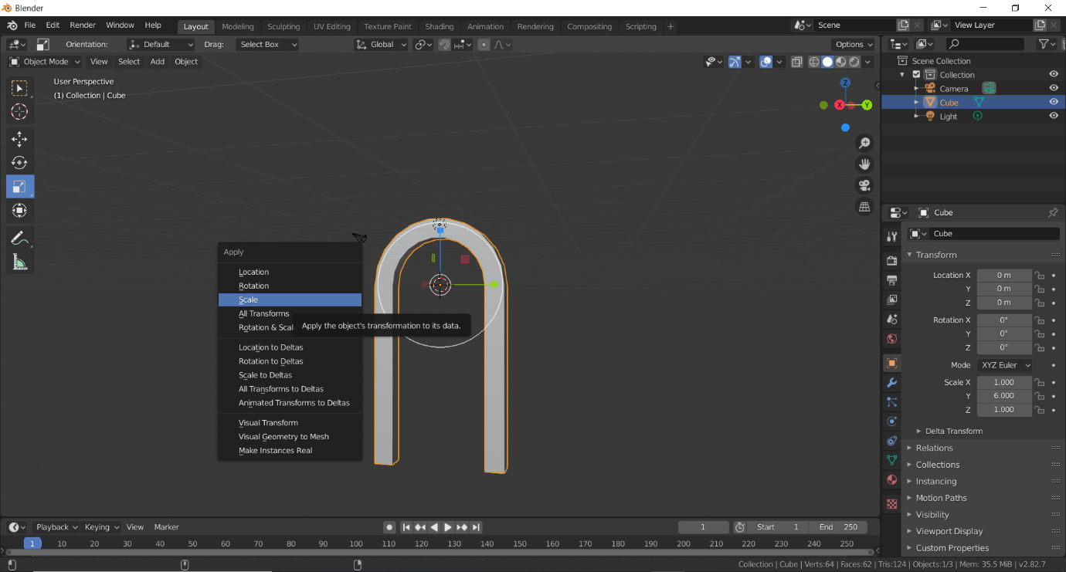

Before doing so, it was important to apply the archway’s transformation to its data. This will have otherwise meant insetting would have been inaccurate.

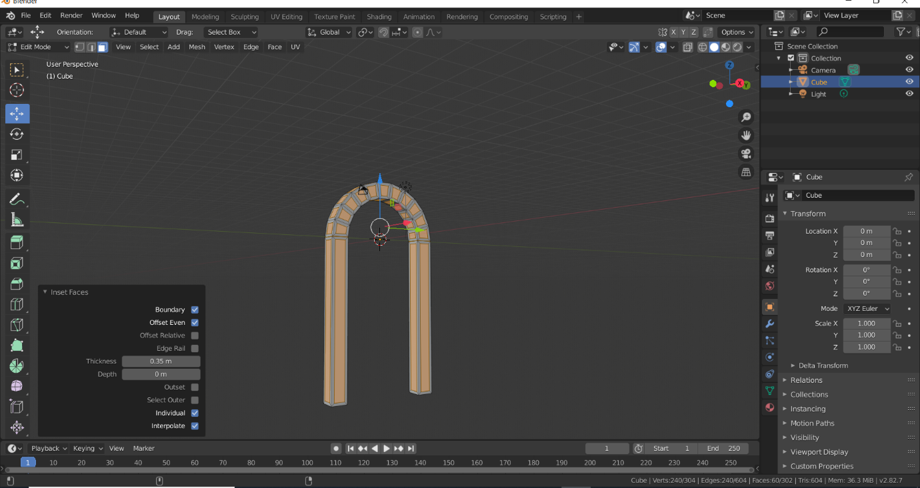

It was also important to “extrude faces along normals”. Otherwise, all faces would have been extruded in the same direction.

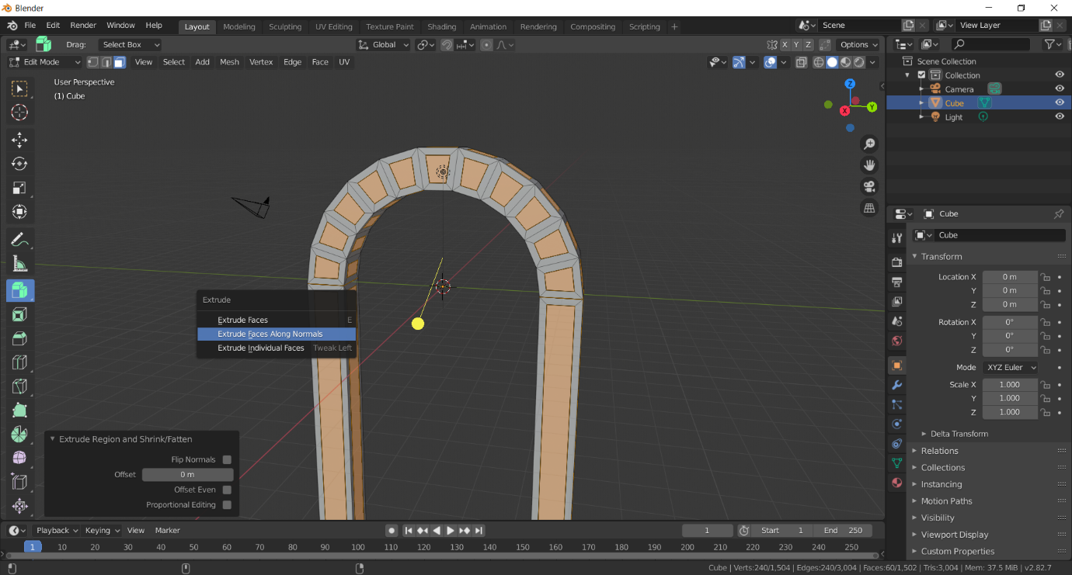

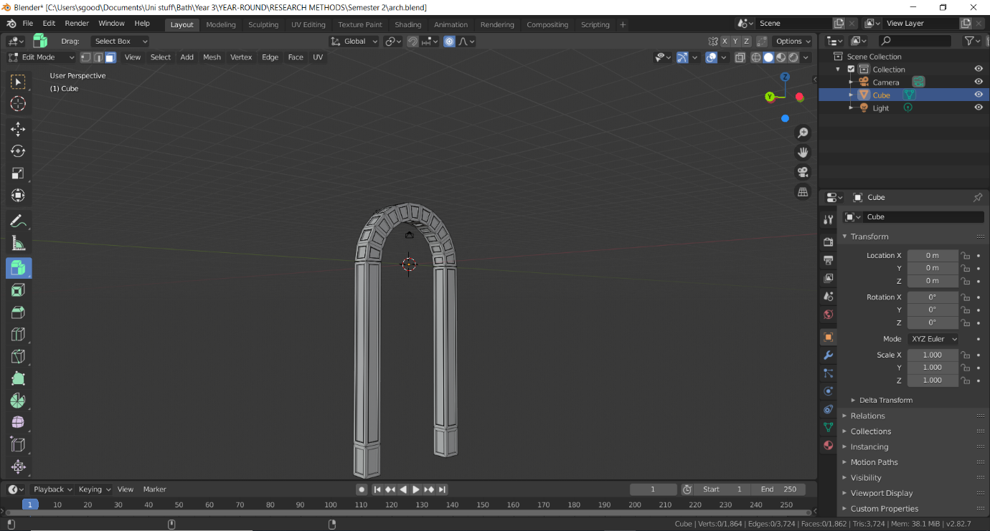

The final product is displayed above. From there, it was combined with the already modelled windows. Its first iteration can be viewed below.

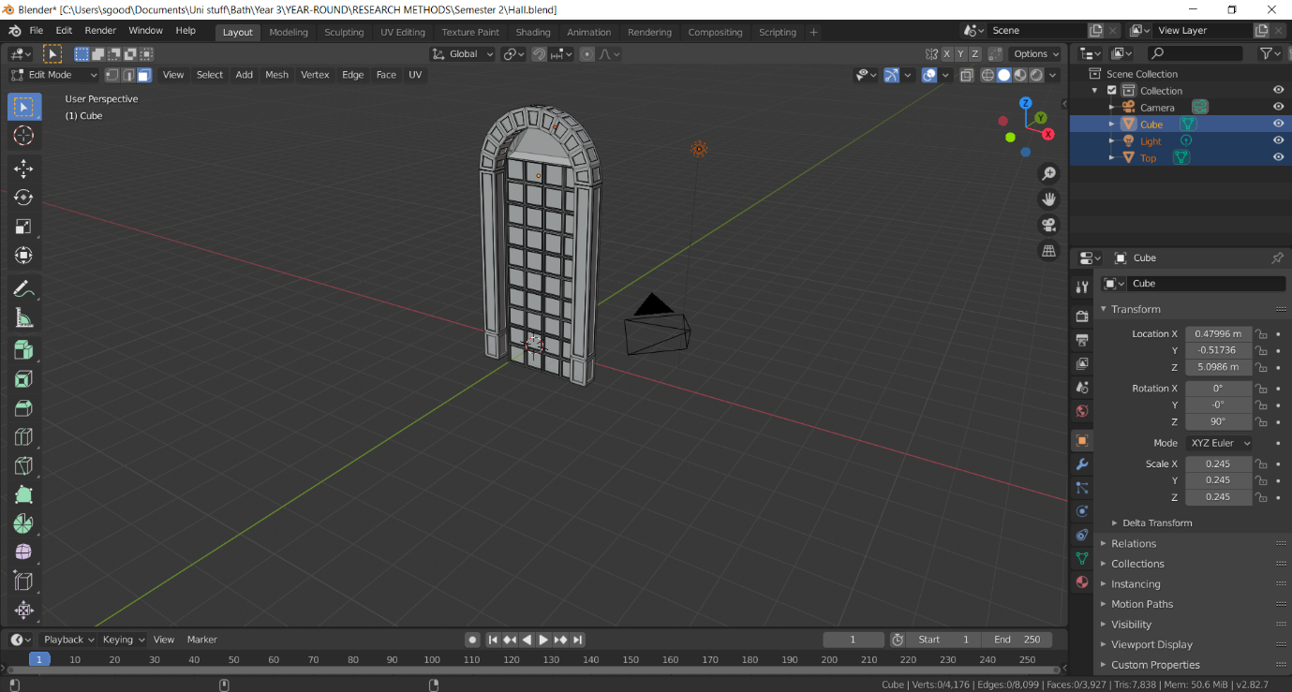

The archway was then extruded, to better represent the reality of the shape.

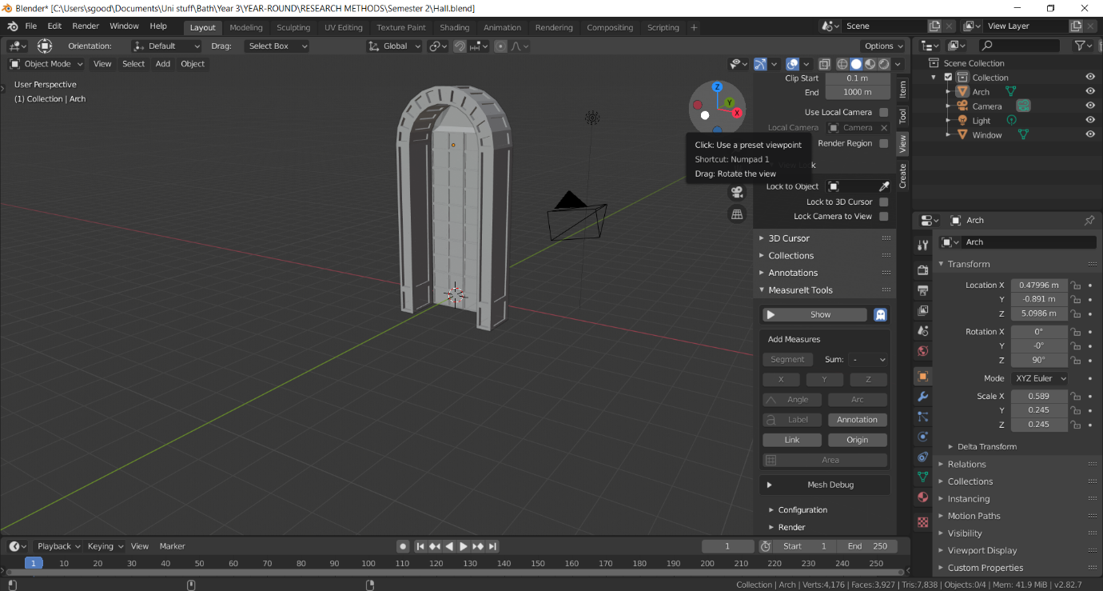

After the arch and window were developed, it was noticed that the number of sides on top were unrepresentative to the Palace’s real life archway. Thus, it was remade with the appropriate number of sides.

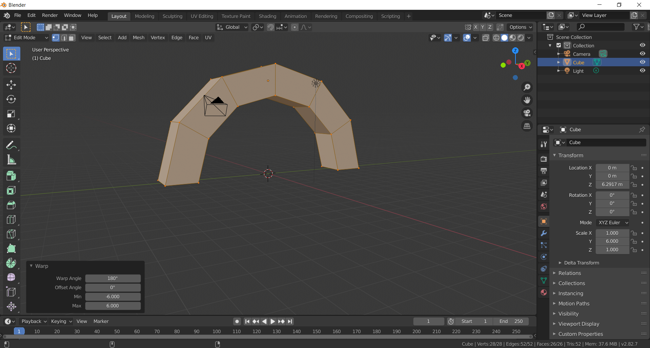

The new version of the arch and window can be seen below.

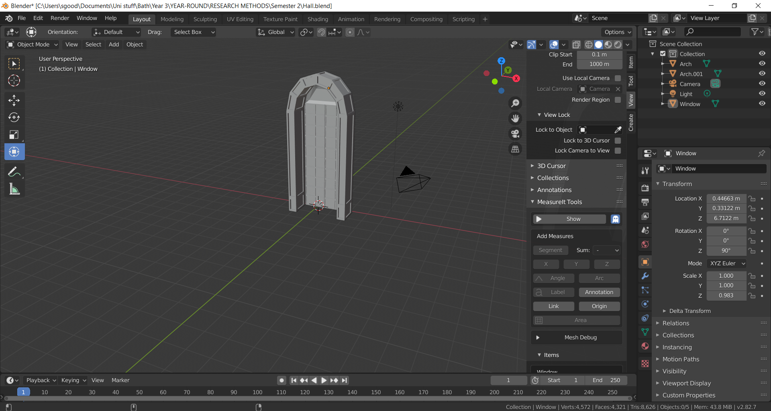

## Week 5

**USE THIS TO SEE THE APPROPRIATE STEPS.**

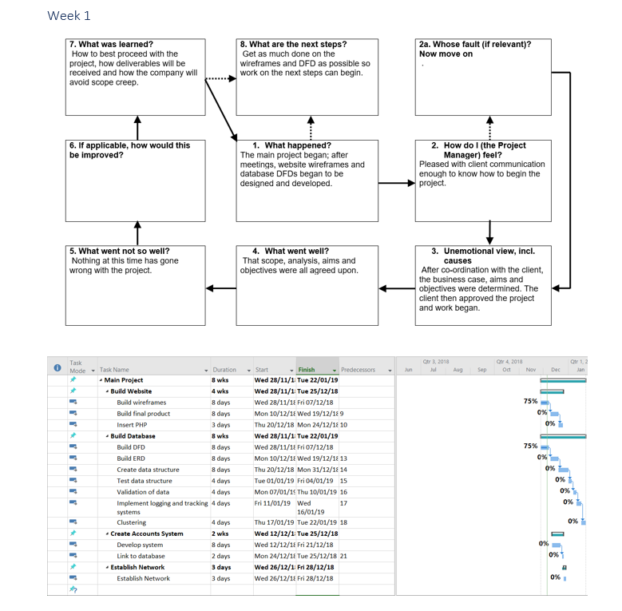

# Appendices

## Week 1

### Software

|  |  |  |
| --- | --- | --- |
| **Name** | **How it will be used** | **Potential risks/constraints regarding the software** |
| 3DSMax | To build and design the 3D models. These will be later put together again in Unity. | Poor accessibility. Lack of familiarity with the software. |
| Unity | To put the 3D objects together, and be explored through the use of an asset such as FPS controller, to simulate walking through the virtual environment. | Poor performance in the virtual environment. |
| Adobe Premiere | To create videos with my narration, to be inserted in appropriate parts of the museum. | Lack of accessibility, as facilities only exist on the college campus. |
| Microsoft PowerPoint | To draw out basic diagrams to visually represent appropriate aspects, when available videos and images are not available to be inserted. | Minimal risks and constraints. |
| Paint | The same purpose of PowerPoint, if in the situation PowerPoint is an unsuitable or inappropriate software to use. | Minimal risks and constraints. |
| WebStorm | For building the website that the data will be gathered and stored from. | A lack of experience and familiarity with the program. |

### Hardware

|  |  |  |
| --- | --- | --- |
| **Name** | **How it will be used** | **Potential risks/constraints regarding the hardware** |
| PC Hardware | To run the Unity program. | Poor performance due to quality of hardware. |
| VR Headset | To simulate the VR. | Lack of familiarity. |

### Personnel

An issue will be finding the participants of both a pilot study, control group and main group for research. For the pilot study, a volunteer sample can be utilised, as it will be small-scale. For both the control group and main group of the research project, co-ordinating with the college to find students willing to take part in the research will be the first plan. If this fails, participants can also be found through extra-curricular activities I take part in. The control group will be a simpler sample to obtain as they do not require to use the VR headset and environment, and can simply read the appropriate passage from a textbook and answer the necessary questions online.